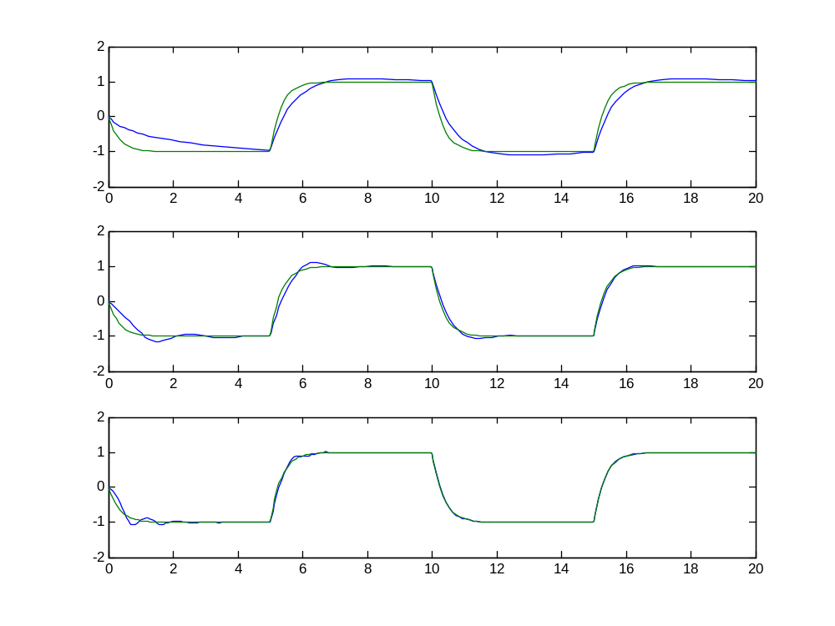
x
time (seconds)
Graph of how process state x converges to the reference model state x_{m} for γ=1, 10, 50
γ=10
γ=50
γ=1

Graph of how the controller gain k(t) and k_{r}(t) evolve for γ=1, 10, 50

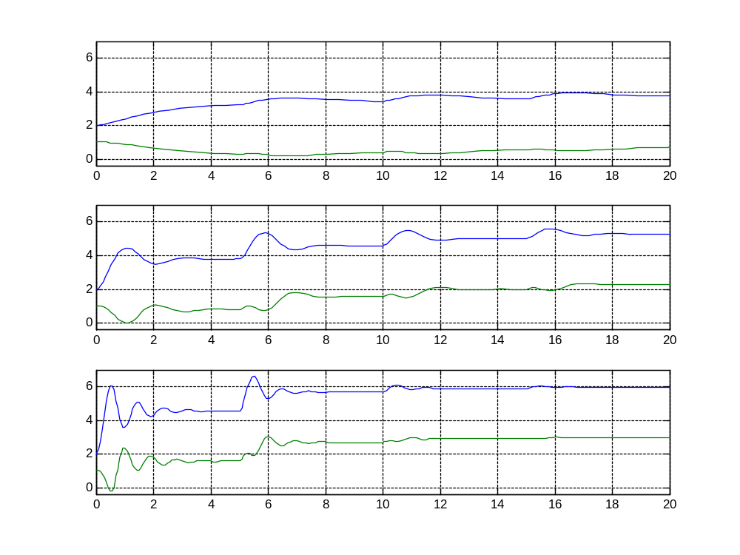
γ=1
time (seconds)
γ=10
γ=50
k_{r}

